ReZyklus SMPS PSU - 01/01/2024 v1.0
This power supply for the ReZyklus is based on a XPower LCW15 Series Switched Mode Power Supply unit which outputs 5V at up to 3 Amps; this output is fed into a DC-DC adjustable boost converter module set to output 5.6V.
The SMPS module can accept a wide range of line voltages between 85 – 305 VAC and the 5V output is adjustable by ±10%. The datasheet can be found here:
https://www.xppower.com/product/LCW15-Series

For this PCB, the input voltage is on CON201 which is a 6-pin Molex KK396 connector. This is wired to be compatible with the original Zyklus PSU. The original unit has a line voltage selector switch, but this SMPS will automatically adjust to a wide range of input voltages, so should operate independently of the how the switch is set. The pinout for input connector is shown below:
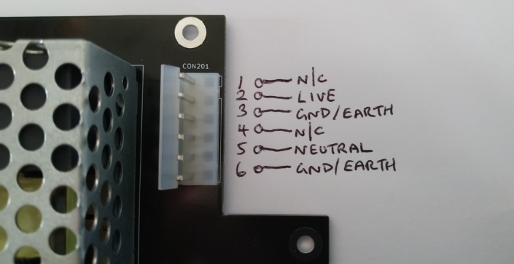
The output voltages are available on connectors CON202 and CON203 which are both 4-pin Molex KK396 connectors; both have the same pinout with +5V, +5.6V (5V6) and 0V (Gnd); one pin on each connector is unused. The pinout for the output connectors is shown on the PCB.

Fuse
There is a 2A fuse on the PCB for the 5V output of the SMPS module (the 5.6V rail is tapped off the 5V line so is also protected by this fuse); this can be replaced with a T2A fuse (time-lag). The line input should also be protected by a fuse (not on this PCB) and a T1A is recommended; note that the SMPS module has a high inrush current on powering on, so a time-lag fuse is required.

Important - Calibration
Before connecting the unit to a ReZyklus board, check the 5V line with a multimeter and, if required, adjust the white trim pot on the SMPS module (see the Vadjust marking on the PCB) to get this close to (but not below) 5V. After doing this, check the +5.6V line and adjust the blue multi-turn trim pot to get this as close to (but not below) 5.6V.

